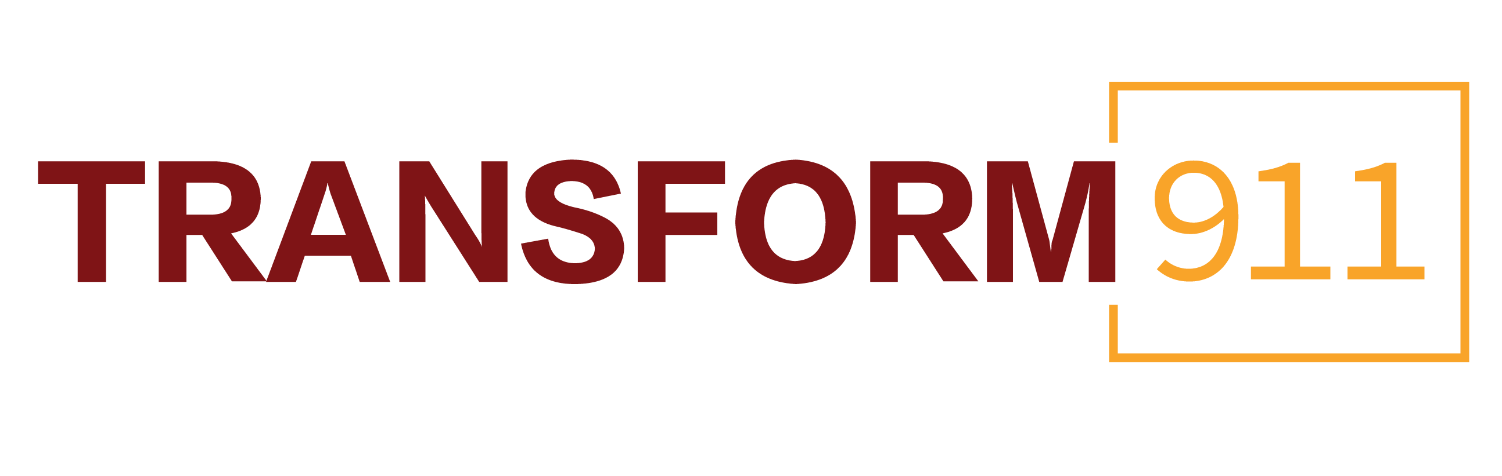
Transform911 Blueprint
Stakeholder Social Posts
Twitter:
- Over 18 months, @T911HealthLab gathered experts to develop a blueprint to transform the nation’s 911 emergency response system. With the blueprint now available, join us as we work to make it a reality. https://www.transform911.org/blueprint/

- Transformative change of the nation’s 911 system is within reach. @T911HealthLab’s new policy blueprint reimagines the capabilities of emergency response, with a focus on public health, safety, and justice. Read the recommendations: https://www.transform911.org/blueprint/

- Everyone knows what 911 is, but almost no one knows how it works. Reintroducing 911 to the American public is a key recommendation of @T911HealthLab’s new policy blueprint. Explore all the recommendations: https://www.transform911.org/blueprint/

- Transforming 911 begins with community partnerships and voices. That’s why it’s part of @T911HealthLab’s blueprint to transform emergency response in America. Learn more: https://www.transform911.org/blueprint/

- Supporting an expert 911 workforce means providing access to high-quality and consistent training, as well as state-of-the-art technology. @T911HealthLab’s policy blueprint calls for greater support of the 911 workforce. https://www.transform911.org/blueprint/

- To create more equitable outcomes in emergency response, 911 communications centers need to be independent and equal to other local first response systems. That’s why it’s part of @T911HealthLab’s blueprint for change. https://www.transform911.org/blueprint/
- Ensuring the right response at the right time is a central component of @T911HealthLab’s new plan for transforming 911 in America. A diverse ecosystem of responses will reduce reliance on police by default. Learn more: https://www.transform911.org/blueprint/
- New data and tech standards that promote transparency are needed within 911. @T911HealthLab’s policy blueprint charts a path toward improving emergency response through reliable and ethical data collection. https://www.transform911.org/blueprint/

- America’s 911 system currently functions through thousands of local emergency communications centers. @T911HealthLab is calling for greater federal support of the nation’s 911 system. https://www.transform911.org/blueprint/

Facebook:
- Transform911, an initiative of the University of Chicago Health Lab, spent over a year gathering experts in the field of emergency response to identify how the nation’s 911 system could be transformed to prioritize public health, community safety, and justice. The final blueprint, which is now publicly available, calls for seven transformative changes to 911 to accomplish that goal. Read the full blueprint today: https://www.transform911.org/blueprint/

- Transform911 released a policy blueprint to modernize and strengthen America’s 911 system. Development of the plan is the culmination of more than 18 months of work by experts in law enforcement public health, emergency response, government, technology, justice, academia, and philanthropy. If implemented, it would be the most comprehensive overhaul of the nation’s 911 system ever. Read the recommendations today. https://www.transform911.org/blueprint/
- It’s time to reintroduce 911 to the American public. Everyone knows 911 as a number, but very few know how it actually works. A new plan from Transform911 would bolster confidence in the nation’s emergency response capabilities while bolstering a career pipeline for 911 professionals. https://www.transform911.org/blueprint/
- A new blueprint plan from Transform911, an initiative of the University of Chicago, prioritizes community voices in 911 emergency response. Community partnerships are essential to creating a 911 system that works for everyone. Read the full blueprint today. https://www.transform911.org/blueprint/
- The nation’s 911 workforce needs access to high-quality and consistent training, as well as state-of-the-art technology. Transform911, an initiative of the University of Chicago, recently released a seven-point blueprint to reimagine how the nation’s 911 system serves communities across the country. Supporting the 911 workforce is a central component of the plan. Learn more today. https://www.transform911.org/blueprint/

- To create more equitable outcomes in emergency response, 911 communications centers need to be independent and equal to other local first response systems. That’s why it’s part of Transform911’s blueprint for change. Explore the full blueprint today. https://www.transform911.org/blueprint/
- Ensuring the right response at the right time is a central component of Transform911’s new plan for transforming 911 in America. A diverse ecosystem of responses will reduce reliance on police by default. Read the full plan and learn more about the Transform911 initiative. https://www.transform911.org/blueprint/
- A key finding of Transform911’s new policy blueprint is that new data and technology standards that promote transparency are needed within 911. Transform911’s blueprint charts a path toward improving emergency response through reliable and ethical data collection. https://www.transform911.org/blueprint/
- America’s 911 system currently functions through thousands of local emergency communications centers. Transform911, an initiative of the University of Chicago, recently released a seven-point policy blueprint to transform emergency response in America. Greater federal support and oversight of 911 is just one of the recommendations. Read the full blueprint today. https://www.transform911.org/blueprint/

###

